**React**

**12. ReactJS-HOL - Create a React Application named “ticketbookingapp” where the guest user can browse the page where the flight details are displayed whereas the logged in user only can book tickets.**

**CODE:**

**Src 🡪 components**

**GuestPage.js**

import React from 'react';  
  
function GuestPage() {  
 return (  
 <div>  
 <h2>Welcome, Guest!</h2>  
 <p>Browse flights below:</p>  
 <ul>  
 <li>Flight A - 10:00 AM</li>  
 <li>Flight B - 3:00 PM</li>  
 <li>Flight C - 8:00 PM</li>  
 </ul>  
 </div>  
 );  
}  
  
export default GuestPage;

**UserPage.js**

import React from 'react';  
  
function UserPage() {  
 return (  
 <div>  
 <h2>Welcome, User!</h2>  
 <p>You can now book your flight tickets:</p>  
 <button>Book Flight</button>  
 </div>  
 );  
}  
  
export default UserPage;

**App.js**

import React, { useState } from 'react';  
import GuestPage from './components/GuestPage';  
import UserPage from './components/UserPage';  
  
function App() {  
 const [isLoggedIn, setIsLoggedIn] = useState(false);  
  
 const handleLogin = () => setIsLoggedIn(true);  
 const handleLogout = () => setIsLoggedIn(false);  
  
 let page;  
 let button;  
  
 if (isLoggedIn) {  
 page = <UserPage />;  
 button = <button onClick={handleLogout}>Logout</button>;  
 } else {  
 page = <GuestPage />;  
 button = <button onClick={handleLogin}>Login</button>;  
 }  
  
 return (  
 <div className="App" style={{ padding: '20px' }}>  
 <h1>Flight Ticket Booking App</h1>  
 {button}  
 <hr />  
 {page}  
 </div>  
 );  
}  
  
export default App;

**OUTPUT:**

**GuestPage**

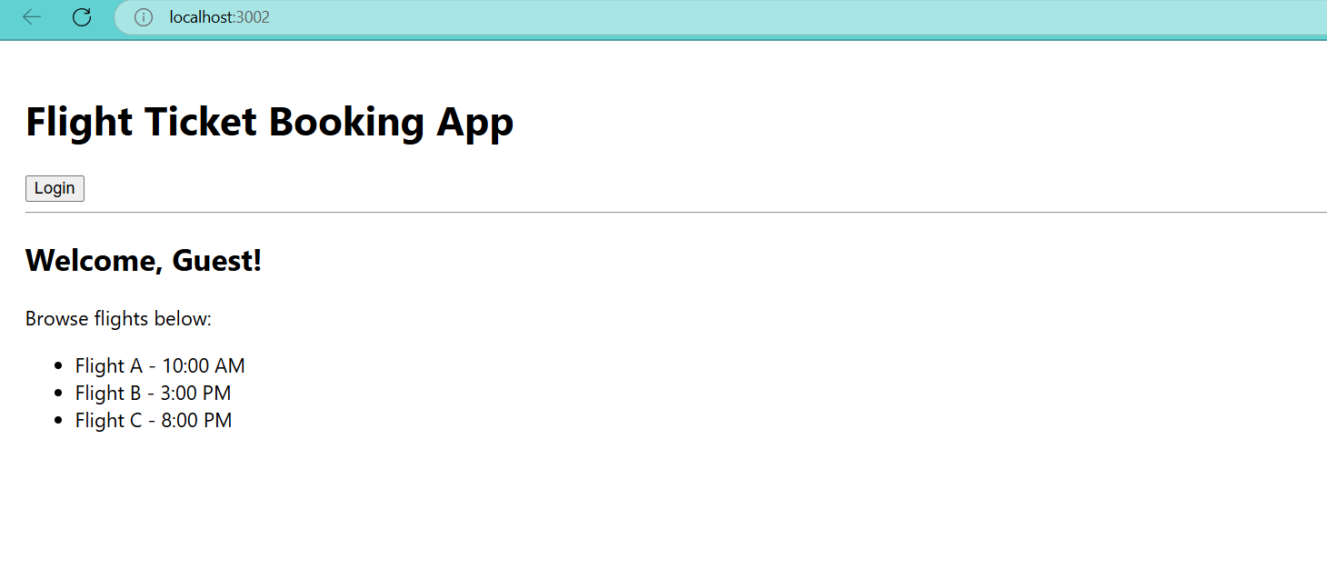

**UserPage**

